WhatNext Vision Motors: Shaping the Future of Mobility with Innovation and Excellence

User Story:
WhatsNext Vision Motors is revolutionizing its customer experience and operational efficiency with a cutting-edge Salesforce CRM implementation. The project streamlines the vehicle ordering process by auto-assigning orders to the nearest dealer based on customer location and preventing orders for out-of-stock vehicles. Automated workflows update order statuses dynamically and send scheduled email reminders for test drives. Key technical implementations include Apex triggers for stock validation, batch jobs for stock updates, and scheduled Apex for automated order processing. This initiative enhances customer satisfaction, improves order accuracy, and boosts overall operational efficiency.

1. INTRODUCTION

1.1 Project Overview :

WhatNext Vision Motors implemented a Salesforce-based CRM solution to modernize vehicle ordering and dealership operations. The system automates vehicle order placement, validates stock availability, assigns orders to the nearest dealer, schedules test drive reminders, and updates order statuses dynamically. This transformation replaces manual and disconnected processes with a centralized, automated platform, improving operational efficiency and customer satisfaction.

1.2 Purpose :

The purpose of this project is to automate vehicle ordering, stock management, dealer assignment, and customer engagement using Salesforce CRM. The system aims to reduce manual intervention, eliminate order errors, provide real-time tracking, and enhance overall business productivity while delivering a seamless customer experience.

2. IDEATION PHASE

2.1 Problem Statement (Customer Problem Statement Template)

PS | I am  (Customer) | I’m trying to | But | Because | Which makes me  feel
PS-1 | Operations Manager | manage vehicle orders | stock info is manual | systems are disconnecte d | stressed
PS-2 | Customer | place vehicle orders | availability unclear | delayed updates | uncertain

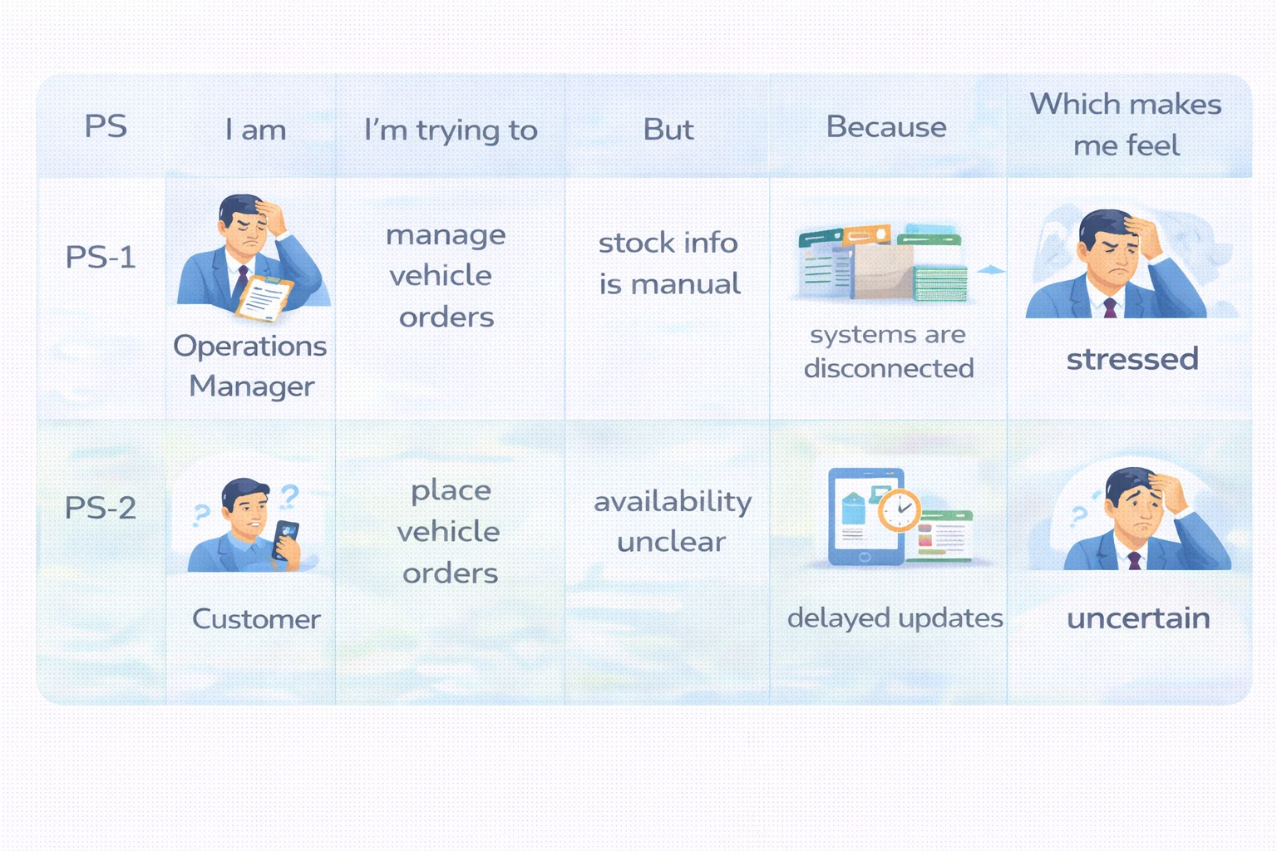

2.2 Empathy Map Canvas
User Persona: Operations Manager
- Think & Feel: Concerned about wrong orders & stock errors
- Hear: Dealer and customer complaints
- See: Registers & spreadsheets
- Say & Do: Manual follow-ups
- Pain: Delays & cancellations
- Gain: Automation & dashboards
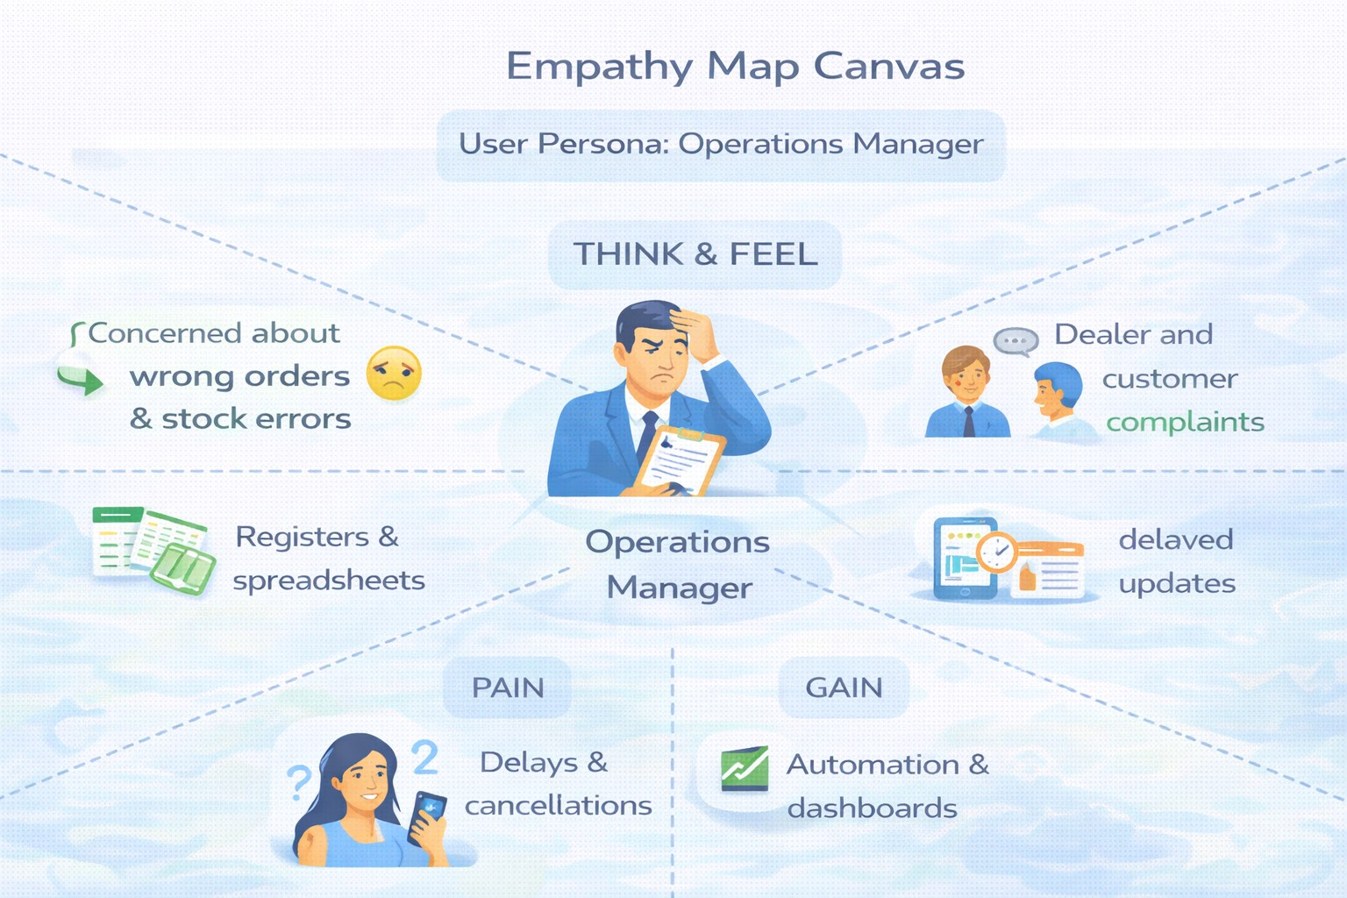

2.3 Brainstorming & Idea Prioritization

Ideas Considered
- Manual registers
- Spreadsheet tracking
- Standalone portal
- Salesforce CRM

Final Selection
Salesforce CRM selected due to:
- Automation
- Scalability
- Real-time visibility

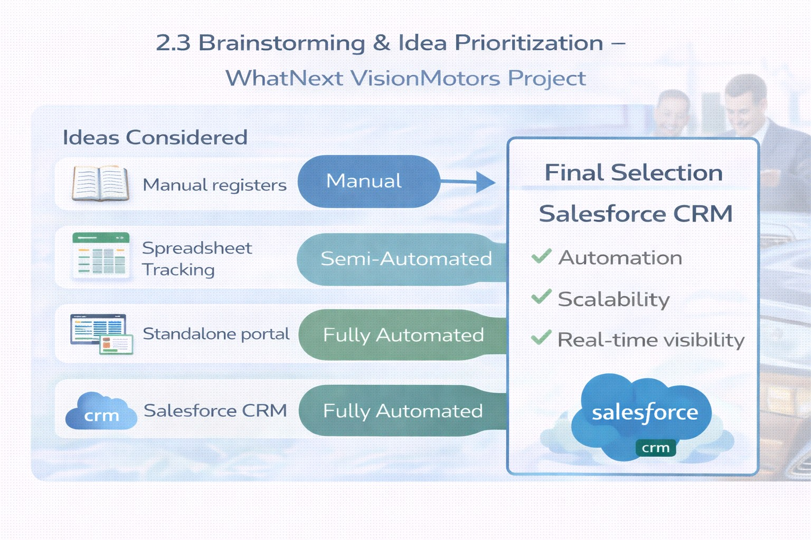

3.REQUIREMENT ANALYSIS PHASE

3.1 Customer Journey Map

Stages:
● Inquiry → Vehicle Selection → Order Placement → Dealer Assignment → Stock Validation → Test Drive → Confirmation → Reporting

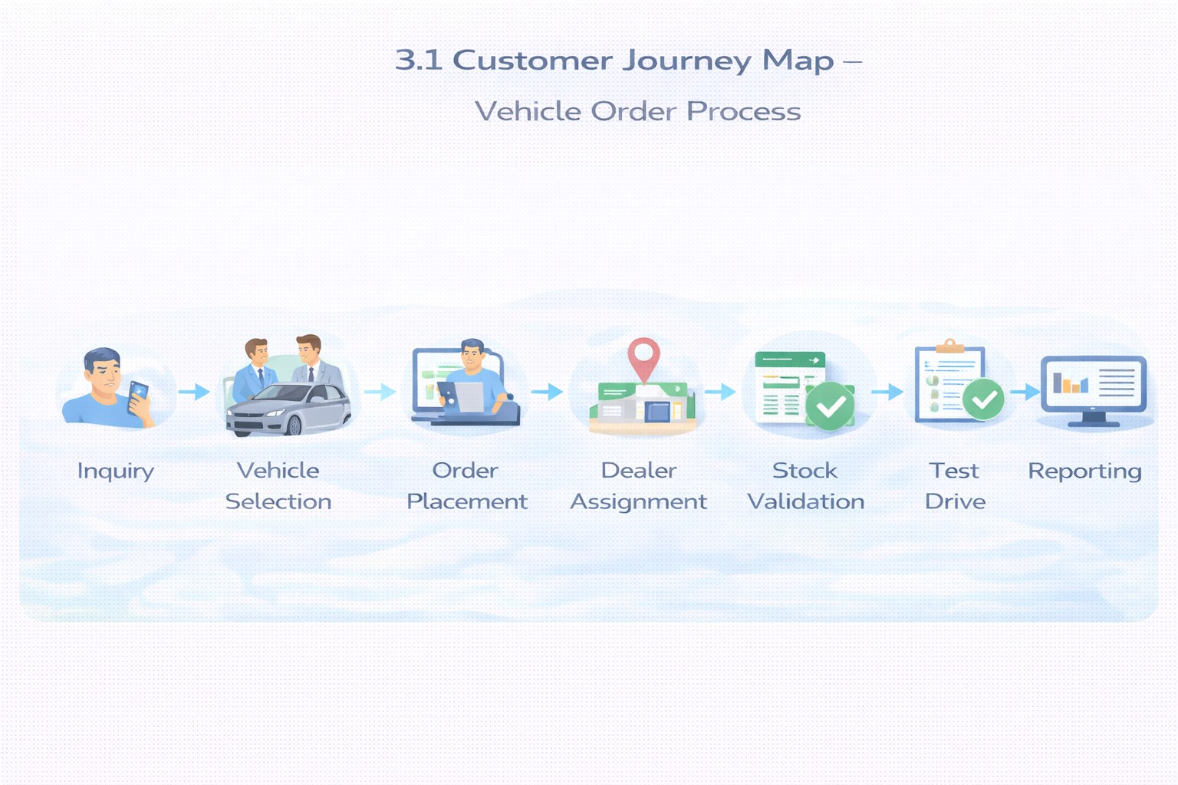

3.2 Solution Requirements

Functional Requirements

FR No | Requirement
FR-1 | Vehicle management
FR-2 | Dealer management
FR-3 | Customer order creation
FR-4 | Stock validation
FR-5 | Dealer auto-assignment
FR-6 | Test drive scheduling
FR-7 | Reports & dashboards

Non-Functional Requirements

NFR | Description
Usability | Lightning UI for easy navigation
Security | Role-based access control
Reliability | Accurate automation
Performance | Fast order processing
Availability | 24/7 cloud access
Scalability | Multi-dealer support

3.3 Data Flow Diagram
Flow:
Customer Input → Order Creation → Stock Validation → Dealer Assignment → Status
Update → Reports
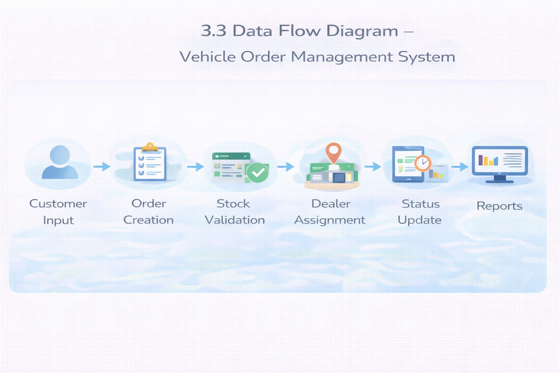

3.4 Technology Stack
Layer | Technology
UI | Salesforce Lightning
Logic | Salesforce Flows
Database | Salesforce Objects
Automation | Validation Rules, Triggers
Processing | Batch Apex, Scheduled Apex
Reporting | Reports & Dashboards

4. PROJECT DESIGN PHASE

4.1 Problem–Solution Fit
The system eliminates fragmented operations by integrating automated stock validation, dealer assignment, and order processing within Salesforce.
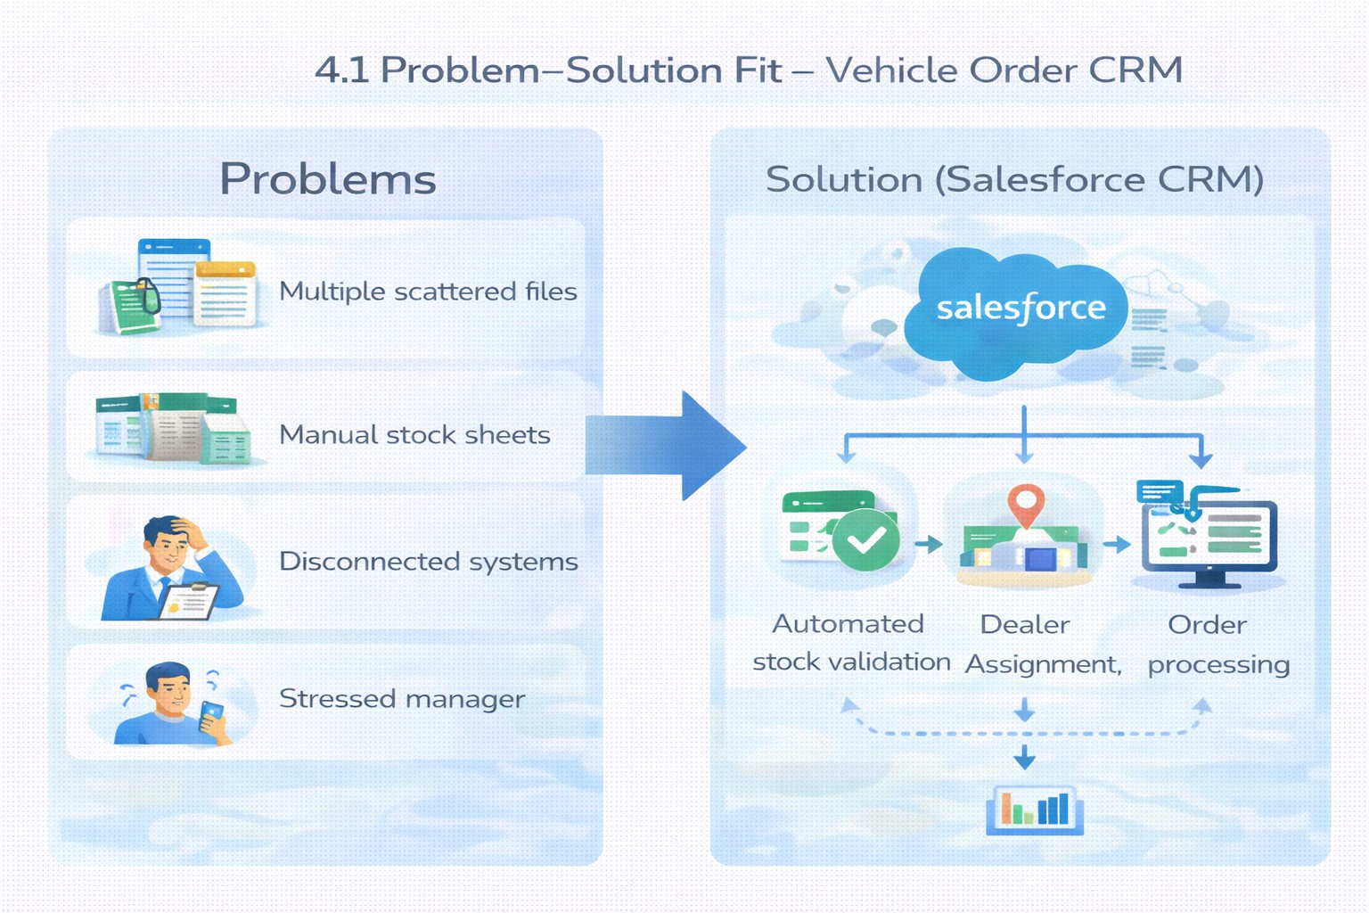

4.2 Proposed Solution

Functional Requirements

Parameter | Description
Problem | Manual vehicle ordering
Solution | Salesforce CRM
Innovation | Automated dealer assignment
Impact | Faster service
Business Model | Dealer network
Scalability | Multi-location support

4.3 Solution Architecture Components:
- Vehicle Object
- Dealer Object
- Customer Object
- Order Object
- Test Drive Object
- Service Request Object
- Flows
- Apex Triggers
- Batch Jobs
- Reports
- Dashboards

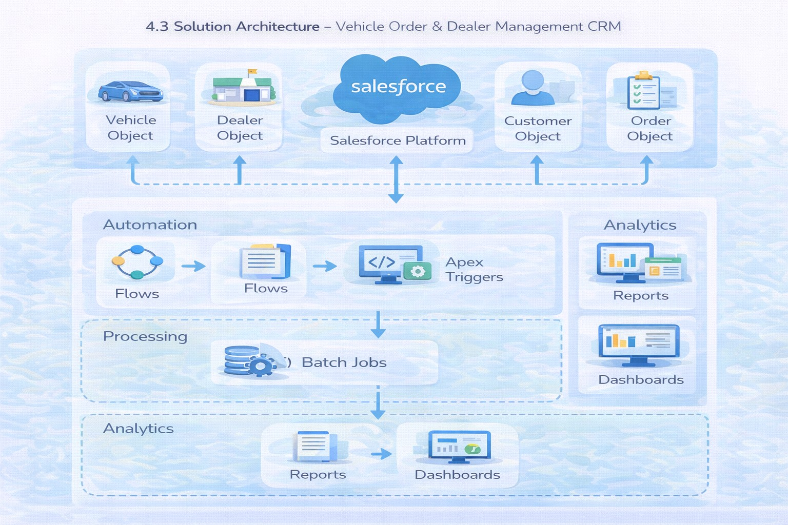

5. PROJECT PLANNING & SCHEDULING
5.1 Project Planning
- Agile methodology
- Epics → Stories → Story Points
- Sprint-based execution
Sprint | Functional  Requirement  (Epic) | User  Story  Number | User Story / Task | Story Points | Priority | Team Member  s
Sprint-1 | Developer Setup | USN-1 | As a system administrator, I want to create and configure a Salesforce developer account so that I can build and deploy the vehicle order management system. | 3 | High | Member1
Sprint-2 | Data Modeling | USN-2 | As an admin, I want to create  Vehicle, Dealer, Customer, Order, | 5 | High | Member2

Sprint | Functional  Requirement  (Epic) | User  Story  Number | User Story / Task | Story Points | Priority | Team Member  s
 |  |  | and Service Request objects with proper relationships so that all business data is stored and managed systematically.
Sprint-2 | Data Modeling | USN-3 | As a staff member, I want dedicated tabs and a Lightning App for all modules so that I can easily navigate and manage vehicle orders and dealer operations. | 5 | High | Member3
Sprint-3 | Automation | USN-4 | As a system, I want to validate stock availability, mandatory fields, and order inputs so that invalid or incomplete vehicle orders are prevented. | 3 | High | Member4
Sprint-3 | Automation | USN-5 | As a sales coordinator, I want automated flows to assign the nearest dealer and update order status so that processing becomes faster and requires minimal manual effort. | 3 | High | Member4
Sprint-4 | Apex | USN-6 | As a system, I want Apex triggers to automatically perform actions such as order confirmation and dealer assignment so that critical processes occur instantly and accurately. | 5 | High | Member1
Sprint-4 | Apex | USN-7 | As an inventory manager, I want batch jobs to update vehicle stock levels automatically so that inventory data remains accurate and up to date. | 5 | High | Member2
Sprint-5 | Reports | USN-8 | As a manager, I want reports showing order status, dealer performance, and sales metrics so that I can monitor operations and make informed decisions. | 4 | High | Member3
Sprint-6 | Dashboards | USN-9 | As a manager, I want dashboards showing order status, dealer performance, and sales metrics so that I can monitor operations and make informed decisions. | 4 | Medium | Member4
6. PROJECT DEVELOPMENT PHASES
Phase 1: Salesforce Account & Environment Setup
The project begins by creating and configuring the Salesforce development environment. A Salesforce Developer Account is created and activated, providing the platform required to develop, configure, test, and deploy the application.
Key activities:
- Create Salesforce Developer Account
- Verify and activate the account
- Configure the Salesforce development environment
- Access Salesforce Setup and Object Manager

Phase 2: Data Modelling & Object Creation
The next phase focuses on designing the application's data structure. Custom Salesforce objects are created to represent the major entities involved in vehicle sales and services. Relationships are established between these objects to maintain connected and organized data.
Modules / Objects:
- Vehicle – Stores vehicle information
- Vehicle Dealer – Stores authorized dealer details
- Vehicle Customer – Maintains customer information
- Vehicle Order – Tracks vehicle purchases
- Vehicle Test Drive – Manages test-drive bookings
- Vehicle Service Request – Tracks servicing requirements
Key activities:
- Create custom objects
- Define object relationships
- Establish customer–vehicle–order connections
- Establish customer–vehicle relationships for test drives and service requests Pasted text

Phase 3: Fields & Relationships Configuration
After creating the objects, the required fields are configured for storing detailed information. Different field types such as text, number, currency, email, phone, date, and picklist are used according to the requirements. Lookup relationships connect related records across objects.
Important fields include:
- Vehicle name, model, price and stock quantity
- Vehicle status and dealer relationship
- Customer name, email, phone and address
- Order date and order status
- Test-drive date and status
- Service date, issue description and status
Key activities:
- Create custom fields
- Configure picklist values
- Create lookup relationships
- Define required data formats and statuses Pasted text

Phase 4: Application Interface & Navigation
The application interface is developed using Salesforce Lightning. Custom tabs are created for the different modules, and they are integrated into a single Lightning application called WhatNext Vision Motors. This provides users with centralized navigation to manage vehicles, dealers, customers, orders, test drives and services.
Key activities:
- Create custom tabs
- Build Lightning Application
- Configure application navigation
- Add Vehicle, Dealer, Customer, Order, Test Drive and Service Request modules
- Add Reports and Dashboard
- Configure user profiles Pasted text

Phase 5: Workflow Automation
Automation is introduced to reduce manual operations and improve the efficiency of the vehicle management process. Salesforce Record-Triggered Flows automatically perform actions when specific records are created or updated.
Automation modules:
1. Automatic Dealer Assignment
- Triggered when a vehicle order is created with Pending status
- Retrieves customer information
- Identifies the dealer based on the customer's location
- Assigns the dealer to the order
2. Test Drive Reminder
- Triggered when a test drive is scheduled
- Uses the test-drive date as the time reference
- Sends an email reminder to the customer one day before the test drive Pasted text

Phase 6: Apex & Order Management Logic
Apex programming is used to implement business rules that require more advanced processing than standard Salesforce configuration. An Apex Trigger and Handler are developed for vehicle order processing and stock management.
Key functions:
- Check vehicle availability before placing an order
- Prevent orders when stock quantity is zero
- Detect confirmed orders
- Automatically reduce vehicle stock after confirmation
- Separate trigger logic using an Apex Handler
- Handle both insert and update operations Pasted text

Phase 7: Batch Processing & Scheduling
The final development phase handles pending orders that cannot initially be confirmed because vehicles are out of stock. Batch Apex periodically checks these orders and confirms them when new stock becomes available. A scheduler automates the execution of this process.
Batch processing:
- Identify pending vehicle orders
- Check current vehicle stock
- Confirm orders when stock becomes available
- Reduce the available stock accordingly
Scheduled processing:
- Create a Batch Scheduler class
- Execute the batch job automatically
- Configure the batch execution schedule
- Monitor the scheduled job Pasted text

Overall Development Flow
Salesforce Setup
↓
Data Modelling & Object Creation
↓
Fields & Relationships
↓
Lightning App & Navigation
↓
Workflow Automation
↓
Apex & Business Logic
↓
Batch Processing & Scheduling
↓
Complete Vehicle Management System

7. FUNCTIONAL & PERFORMANCE TESTING

During testing, screenshots were captured from Salesforce to validate vehicle creation, dealer assignment, stock validation triggers, order status updates, batch processing, scheduled reminders, and dashboard analytics. All features were verified to ensure correct functionality and performance.

8. ADVANTAGES & DISADVANTAGES

Advantages
- Centralized data
- Automated workflows
- Real-time reporting

Disadvantages
- Salesforce dependency
- Requires initial configuration effort

9. Conclusion:

The Salesforce CRM implementation at WhatNext Vision Motors successfully modernizes vehicle ordering and dealership management. Automation improves efficiency, accuracy, and customer experience.

10. FUTURE SCOPE
- Mobile ordering app
- Dealer GPS integration
- SMS notifications
- AI-based demand forecasting

11. APPENDIX
- Source Code: Salesforce Configuration
- Dataset: Salesforce Objects
- GitHub / Demo: Salesforce Developer Org

